VIEÐASIS ADMINISTRAVIMAS: TEORINIAI SPRENDIMAI IR PAÞANGÛS MODELIAI: PUBLIC ADMINISTRATION: THEORETICAL SOLUTIONS AND PROGRESSIVE MODELS

QUALITY ASSURANCE FOR PUBLIC ADMINISTRATION: NEW IDEAS
VIEÐOJO ADMINISTRAVIMO KOKYBË: NAUJOS IDËJOS

"Public Administration" ( Lithuanian Public Administration Training Association Journal), www.fmmc.Lt;
No. 2, 2002-2003, pp 22-25, ISSN 1648 - 4541.

Raymond SANER
Centre for Socio-Economic Development, Geneva, Switzerland, www.csend.org

Introduction
The public sector produces a large and growing proportion of goods and services in most OECD countries. They range from non-market services provided in the general government sector, such as public administration and defense, to marketable services, such as telecommunication and postal services, and include merit goods, such as health and education.
OECD countries face several constraints and challenges which make it of paramount importance that the public sector in general and the public administration in particular, is managed as efficiently and effectively as possible. Many public sector organizations are now faced with competition and are hence in need of increased efficiency and effectiveness.
The push towards better management of limited resources is partially due to the external pressures emanating from globalization (e.g.,WTO plurilateral agreements in public procurement) and regionalization (EU integration, NAFTA, FTAA, etc.). An equally strong push comes from internal constraints namely growing budget deficits, technological change (e.g., telecommunications and computerization), and different forms of privatizations. A competent, well functioning public administration is needed more than ever before to manage the current and coming internal and external conflicts and challenges which have arisen to a large extent due to increased globalization and concomitant competitive pressures affecting the private and public sectors. (Farazmand, 2002).
As a result of the above mentioned external and internal pressures, the public sectors of OBCO countries are faced with growing demands for better and more equitable modern management and improved leadership of its governments and civil servants (Saner, 2001). Efforts have been made to improve existing management practices over the last 10 years but the results have been considerably less than expected.

Reasons for a new quality standard
The public sector administration is faced with constraints and tasks, which do not exist in the private sector (e.g., legal requirements demanding impartial treatment of citizens/customers and equal access to service). The civil servants/public managers themselves are governed by public law regulations and the services provided by public offices have to be observant of constraints emanating from a multitude of often-conflicting policies.

Existing quality standards such as ISO 9000:2000 have been used in some of the OECD public administrations but the application has been mostly reserved for the control of external service providers and less for internal management controls within a public administration system.
The reasons for this limited use of existing ISO standards is mostly due to the specific nature of public administration as described above. In particular, a key task of any public administration system is refusal regulatory policymaking (regulatory function) which means knowing how to work with conflicting goals and objectives. Private sector companies do not have to deal with such conflictual tasks. Hence, importing quality systems from private sector to public administration would be inappropriate without adding tools to assess this key function of government.
Experts and scholars representing, for instance, the school of New Public Management have made important initiatives for public administrative reform. The same is true for contract based public administration developed in France and Belgium (Racheline, 1997). Both offer meaningful methods to improve performance of public administration.
However, there exists no quality control of NPM or one single agreed definition neither of NPM or of NPA. Important amounts of money and political capital are being spent for NPM and NPA reforms without quality control. A new standard focusing on the particularities of the public sector is needed be this to guide future public administrative reforms or to safeguard quality standards of public administration in general no matter what persuasion.
Main features of New Public Management and New Public Administration and coverage by quality assessment
Table 1 highlights some of the main features of NPM and NPA and shows their respective coverage by a quality assessment (QA) system. The listed elements of NPM and NPA are non-exhaustive. The main purpose here is to highlight the scope of a QA system and how it could offer an approach that could encompass both systems of public administration.
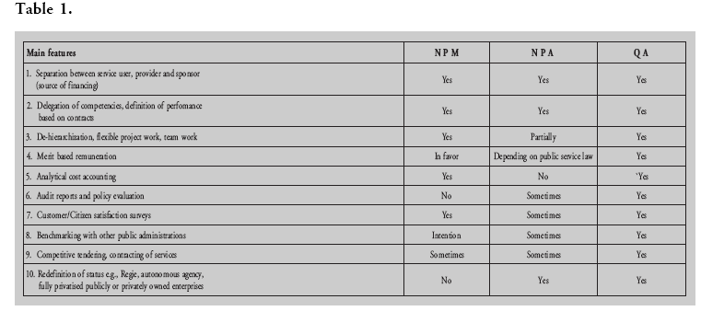

Quality assessment system: A necessary complementary tool for New Public Management and New Public Administration
Different quality assessment systems have been developed over the last years. The most well known and most often used are (1) ISO 9000:2000, (2) the European Foundation for Quality Management (EFQM), (3) the Common Assessment Framework (CAF), and (4) the Excellence Models such as the ones based on EFQM or Speyer. While all of these quality systems offer useful tools and instruments, the following shortcomings have been observed.
Table 1.

- EFQM is a mixture between quality assessment, policy evaluation (output and outcome) and organization development. While it is a very encompassing concept, EFQM can also be experienced as requiring an inordinate amount of resources and time which public administrations often cannot muster.
- The CAP is based onEFQM concepts and methods but according to its developers it remains an intermediary measure leading,. e.g., to a full assessment based on EFQM or other quality systems. The weakness of CAF is its voluntary nature. CAF is only meant for self-assessment. External audits are not foreseen which reduces its attraction for non-governmental stakeholders.
- Quality awards such as the European Excellence Model offer attractive incentives for public administrations to concentrate forces and energy in order to obtain the award. However, once achieved, public administrations tend to relax their discipline leading to a loss of gains previously achieved. In addition, as was pointed out by Loffler (2002), .the questions arise as to whether the criteria measure assesses the right things?.
- ISO 9000:2000 and its previous versions have been used by various public administrations in different parts of the world including Taiwan (Chu et al., 2001). The benefits from using ISO quality instruments are associated with the introduction of standardized procedures making the outcome of events more predictable and giving management more control (Brennan and Douglas, 1999). On the other hand, ISO 9000 instruments have also been reported as being too bureaucratic, the audit process too lengthy and too costly and not satisfactorily covering the policy making process, a core aspect of public administration.
- Switzerland has completed a new guideline titled .Quality Management in the Public Administration. (SNV/2002) which offers quality guidance to interested government officials. The quality guideline can be used as a basis to reach consensus between the executive, legislative and judiciary branches of state administrations. It can also be used to reach common understanding of how a government should provide services to its customer/citizens. The SNV guideline offers suggestions on how to develop a quality system and how to go through the related change management in general. The guideline can be used for any public administration be it organized according to traditional public-administration, NPM administration or NPA administration.
Other countries have also developed ISO related quality instruments for the public administration. For instance, Canada has created the .Guidelines for Implementing ISO 9000 Quality Management Systems in Public Sector organizations. CQSB 184.1 -94, Finland has started an ISO 9000 Pilot Project aiming at municipal service operations; Portugal has developed the .Public Service Quality Charter. and New Zealand is developing unit standards for .Policy Process, Service Delivery and Management in the Public Sector.

Applicability of ISO as consensus mechanism to alleviate stakeholder conflicts
Mandate, structure and performance of public administration remain a thorny and conflictual issue pitching different stakeholders against each other with some arguing for more .service public while others want to see a shrinking role of government. The clashes are at times due to ideological differences (e.g., neoliberal versus conservative concepts of state administration) or often simply based on shrinking budgets and consequently sharp disputes over its allocation of limited budgets.
Another conflict has emerged between constitutional lawyers and representatives of the judiciary who take issue with some of the administrative reforms especially in regards to NPM. They see dangers to constitutional guarantees of equal treatment and warn of discrimination of citizen/customers. On the legislative side, members of parliament (national, provincial or municipal level) fear a loss of democratic control when paired with a NPM type public administration and are uneasy about agreeing to a global
budget and yearly defined strategies without retaining a possibility to intervene as seen needed or politically useful.

The potential for disputes between the different stakeholders has increased. Conflicts emerge between the
different parties, e.g., executive, legislative, judiciary, and civil society as depicted on Figure 1 below.

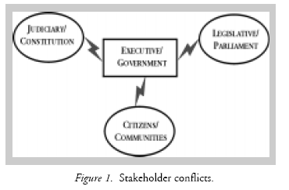

Difference of opinion as to what a public administration should do or not do, how it should be structured, what mandate and means it should be given, all these different and often divergent views can easily lead to paralysis due to lengthy political battles. These battles are of great importance since they determine the future shape and function of our governments. However, they can also stifle attempts to conduct quality assessments now.
Quality assessments are useful at any time of our societal developments. Once the various stakeholders have agreed to the idea, an agreement could be reached to ensure quality of the current government structure and administrative performance. A quality system based on ISO concepts but further developed to fit the complexities of government can easily be adapted to NPM,NPA or a traditional public administration as for instance suggested by Figure 2.

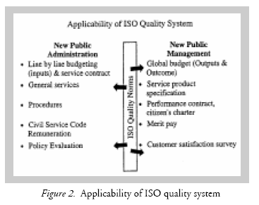

Once it has been agreed to use an ISO quality instrument, the various stakeholders could agree to create a committee overseeing the application of the ISO quality system. While it is better to leave the actual quality audit to an outside professional organization, it could nevertheless be envisaged that the committee members could be involved in the process at the beginning (defining contract) as well as at the end (e.g., discussion of audit results and decision on implementation measures).
A quality measurement system hence would offer a middle ground for different stakeholders to meet and to agree on criteria to be assessed by the quality audit team independently whether the respective public administration is organized along NPM or NPA principles.
The different parties could engage in constructive dialogue with the other constituencies, monitor the process and at the end, as a multistakeholder team, discuss and agree on the improvements, which might have been identified by the ISO auditor (see Figure 3.).

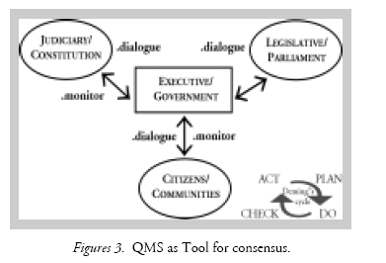

Conclusions
Globalization has presented our governments with many challenges and opportunities. Faced with budget constraints, increasing demands by the public and political pressures from political parties, many public administrations have undergone significant reforms be this following NPM or NPA concepts and principles.
However, neither of the two main new orientations have encouraged nor facilitated the development of a quality assessments measure which would allow the public and the concerned civil servants the opportunity to assess the quality of NPM/NPA claims of superior performance and which would give the concerned actors the opportunity to engage in continuous improvement of administrative performance.
Initiatives have been recorded in several countries in terms of developing quality assessment methods based on EFQM, CAF, ISO or excellence models. Taking into account the shortcomings of all the above mentioned quality approaches, this article proposes adoption and further development of an ISO based guideline, which has recently been published by the Swiss Norm Society. The new quality guidelines offer sufficient common ground for ail schools of thought (including NPM or NPA). It can be used as a consensus building instrument which in turn can help reduce time and energy being lost due to lengthy, often inclusive, and wasteful political battles about the ideal shape of today’s governments and public administration systems worldwide.

Notes
1. The author is Director of CSEND, a non governmental research and development organization (NGRDO) based in Geneva, Switzerland.
2. Parts of this article have been presented at the 10th Annual Conference of NISPAcee (The Network of Institutes and Schools of Public Administration in Central and Eastern Europe), Cracow, April 2002.
3. An excellent background document on policy making and quality of regulatory function was developed by the OECD titled .Recommendation of the Council of the OECD on Improving the Quality of Government Regulation., (1995), OECD-PUMA, Paris.
4. For more information on ISO QA systems: www.iso.org
5. .Guidelines for self-assessment in public sector: Education and Training., www.efqm.org; A further improvement on EPQMis the .Public Sector Quick-Scan. (2000) developed by Northedge b.v.; Gouda, Netherlands, contact: info@northedge.nl
6. Download possibility at www.eipa.nl
7. Qualitats management in der offentlichen Verwaltung (Quality Management in the Public Administration) Swiss Norm Association (SNV), Beuth Verlag, Berlin, Zurich, Vienna, 2002 (ISBN 3-410-15362-4).

Summary
Public administrations in all parts of the world are faced with multiple pressures to innovate and improve effectiveness and efficiency. Reforms range from New Public Administration (NPM) to other forms of reorganizations like .gestion publique par contrats. (France, Belgium) resulting in various forms of New Public Administrations (NPA). While many of these reforms may have proven successful, criticism vis-à-vis all forms of public administrative reforms have increased. Neither NPM nor NPA have a documented track record of success and debates abound about the democratic legitimacy of NPM or the economic effectiveness of NPA. Concerned citizens and government officials alike are looking for methods to find a common ground to assess the quality of public administrations be they based on NPM or NPA. Quality assessment methods offer a transparent method of assessing the performance of public administrations. This article proposes such a quality method based on an adapted version of the ISO Quality guideline as the one recently developed by a working group within the Swiss national quality association.

References
1.Bovaird, Tony, and Elke Loftier. (2002). .Moving From Excellence Models of Local Service Delivery to Benchmarking Good Local Governance.. International Review of Administrative Sciences 68, 15.
2.Brennan, C., and A. Douglas. (1999). .Striving for Continuous Improvement: The Experience of UK Local Government Services. Quality Congress. ASQC Annual Quality Congress Proceedings, pp. 414-422.
3.Chu, P.Y., C.C. Huang, and H.J. Want, (2001). .ISO 9000 and Public Organizations in Taiwan: Organizational Differences in Implementation Practices with Organization Size, Unionization and Service Types.. Public Organization Review 1, 391-413.
4.Farazmand, Ali. (2002). Administrative Ethics and Professional Competence: Accountability and Performance under Globalization. International Review of Administrative Sciences 68(1), 2002, 131-137, March.
5.Qualitatsmanagement In der öffentlichen Verwaltung (Quality Management in the public Administration) (2002), Swiss Norm Association (SNV), Beuth Verlag, Berlin, Zurich, Vienna.
6.Racheline, Francois. (1997). Le dispositif de la gestion delegue. Revue Francaise de Gestion, Numero Special, 115, September-October.
7.Saner, Raymond. (2001). .Globalization and its Impact on Leadership Qualification in Public Administration.. International Review of Administrative Sciences 67(4), 650-661.
8.Saner, Raymond, Lichia Yiu, and Philippe Levy. (1999). Quality Assurance and Reforms of Public Administration: New Developments in-Switzerland.. Paper presented at 1999 Annual Conference of HAS (International Institute of Administrative Sciences), Sunningdale, U.K.; reprinted (1999) as .Riforma della Amministrazione e Qualita: L.esperienza della Svizzera., in Azienda Pubblica. Rimini-Italy, Nr. 5, Septembre.

VIEÐOJO ADMINISTRAVIMO KOKYBË: NAUJOS IDËJOS
Raymond SANER
Centre for Socio-Economic Development, Geneva, Switzerland
Santrauka

Visose pasaulio analyse vie_asis administravimas susiduria su daugialypiais sunkumais efektyvumo ir produktyvumo tobulinimo srityje. Daugelis reformø prasidëjo nuo naujojo vieðojo administravimo (NPM) ir tæsësi iki naujojo vieðojo administravimo (NPA) reorganizacijos formø. Daugelis ið ðiø reformø privalëjo árodyti savo sëkmingus laimëjimus. Dauguma pilieèiø bei valstybës pareigûnø ieðko metodø norëdami surasti bendrà tikslà - ávertinti vieðojo administravimo kokybæ. Kokybës vertinimo metodologija siûlo aiðkø vieðojo administravimo veiklos metodà. Ðiame straipsnyje pateikiamas kokybës vertinimo modelis, naudojamas kaip ISO kokybës standartas, kuris nesenai buvo sukurtas, dirbant kartu su Swiss kokybës asociacija.

