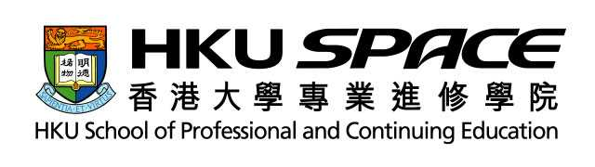
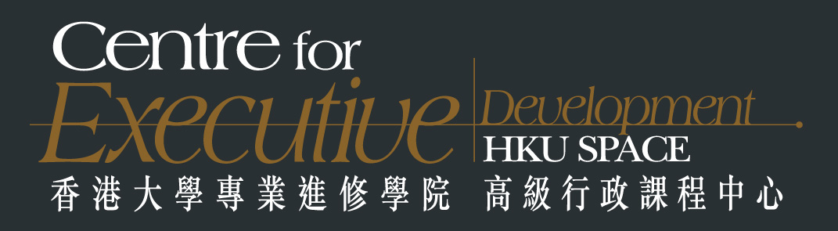International Seminar on e-Education & e-Learning:
Benchmarking the Best Practices in Using Information Technology
Monday 28 June 2004
Room S204, HKU SPACE Admiralty Learning Centre
Objective:
The rapid advancement of information technology has continued to create major changes in various sectors of the knowledge-based economy. Education and learning are also transforming quickly from the conventional face-to-face mode of operation to the e-mode.
This seminar aims at providing an opportunity for senior officials, academics, experts and professionals from UK, Australia, Switzerland, Mainland China, Macau and Hong Kong to share and benchmark the best practices in e-Education and e-Learning as well as to discuss ideas and issues which will shape the future of education and learning.
Organizer:
HKU School of Professional and Continuing Education
Co-organizer:
- Macao Polytechnic Institute
Supported by:
- Information Technology Services Department, HKSARG
- Hong Kong Education City Ltd.
- Hong Kong Association of Heads of Secondary Schools
- Hong Kong Education Research Association
- Hong Kong Public Administration Association
- The British Computer Society (Hong Kong Section)
Sponsored by:
- Intel Ltd.
- 2C Company Ltd.
- Hewlett-Packard Company Ltd. (to be confirmed)
- Longman Hong Kong Education (to be confirmed)
Registration Fee:
Regular | HK$1,500
Early Bird (Register before 8 June 04)  Or  Group Discount (3 ⁺ from same organization) | HK$1,300
Early Bird and Group Discount | HK$1,100
Members of Organizer, Co-organizer, Sponsors and Supporting Organizations | Additional 10%
Language:
English
Who Shall Attend:
- Heads of Schools and Teachers
- Government Officials
- Business Executives
- Professionals in e-Learning and e-Education
- IT Practitioners and IT Suppliers
International Seminar on e-Education & e-Learning:
Benchmarking the Best Practices in Using Information Technology

Programme
Chairman: Dr. Peter Fong, Principal Programme Director, HKU SPACE
8:30 – 9:00 | Registration
9:00 – 9:05 | Welcoming Address:  Professor Enoch Young, Director, HKU SPACE, Hong Kong
9:05 – 9:20 | Keynote Address:  Mr. Alan Wong, Director, Information Technology Services Department, HKSARG, Hong Kong  “Hong Kong - An Evolving E-Learning Society”
9:20 – 9:35 | Keynote Address:  Professor Lei Heong Iok, President, Macao Polytechnic Institute, Macao  “e-Learning in Macao”
9:35 – 10:05 | Professor Laurie Cuthbert, Head of Department of Electronic Engineering, Queen Mary University of London, U.K.  “Distance Learning: An Opportunity and a Challenge?”
10:05 – 10:35 | Mr. Paul Darbyshire, School of Information Systems, Victoria University of Technology, Australia  “The Role of Student Satisfaction in Building Quality Online Programmes”
10:35 – 10:50 | Coffee Break
10:50 – 11:20 | Prof. Lichia Saner-Yiu, President, Academy for Quality in Training and Education, Switzerland  “How to Ensure ROI in e-Training and e-Education: ISO10015 Certification as a Learning System Management Solution”
11:20 – 11:50 | Professor Wu Jiang, Director General, China e-Government Research Centre, National School of Administration, China  “Training Senior Civil Servants in China Through e-Learning”
11:50 – 12:20 | Ms. Jacqueline Cheng, CEO, Hong Kong Education City Ltd., Hong Kong  “Hkedcity.net – A Major Strategy of Applying IT in Education Development in Hong Kong”
12:20 – 12:50 | Dr. Allan Yuen, Head, Division of Information Technology Studies, Faculty of Education, HKU, Hong Kong  “Comparative Pedagogical Innovations Using Technology: An International Comparative Case Study”
12:50 – 14:00 | Lunch
14:00 – 14:30 | Mr. Trevor Lui, Senior Consultant, Hong Kong Productivity Council, Hong Kong  “e-Learning Benchmarking Study: Strategy and Technology for Building Human Capital”
14:30 – 15:00 | Dr. Bruce Cheung, Senior Programme Director, HKU SPACE, Hong Kong  “The Online Universal Learning Project for Students and Teachers”
15:00 – 15:30 | Dr. Christopher Tan, Lecturer, University of South Australia, Australia  “Inter-school Project Work through Collaborative Knowledge Building in Online Knowledge Community”
15:30 – 15:50 | Coffee Break
15:50 – 17:20 | Concurrent Workshop: e-Learning  Moderator:  Mr. Trevor Lui, Senior Consultant, HKPC,  Hong Kong  1. Mr. Arthur Cheung, Senior Consultant, HKPC, Hong Kong  2. Mr. Kelvin Fung, Principal Consultant, Learning Matrix International, Hong Kong  3. Representative from sponsor | Concurrent Workshop: e-Education  Moderator:  Dr. FT Chan, Head, Division of Information Technology, HKU SPACE, Hong Kong  1. Dr. Richard Wong, Partner & Consultant, China Electronic Information Technology Ltd., Hong Kong  2. Representative from sponsor
17:20 | End of Programme

